CNIB Lake Joe
2021 Camp Program
Enriching lives. Making memories. Building Independence.
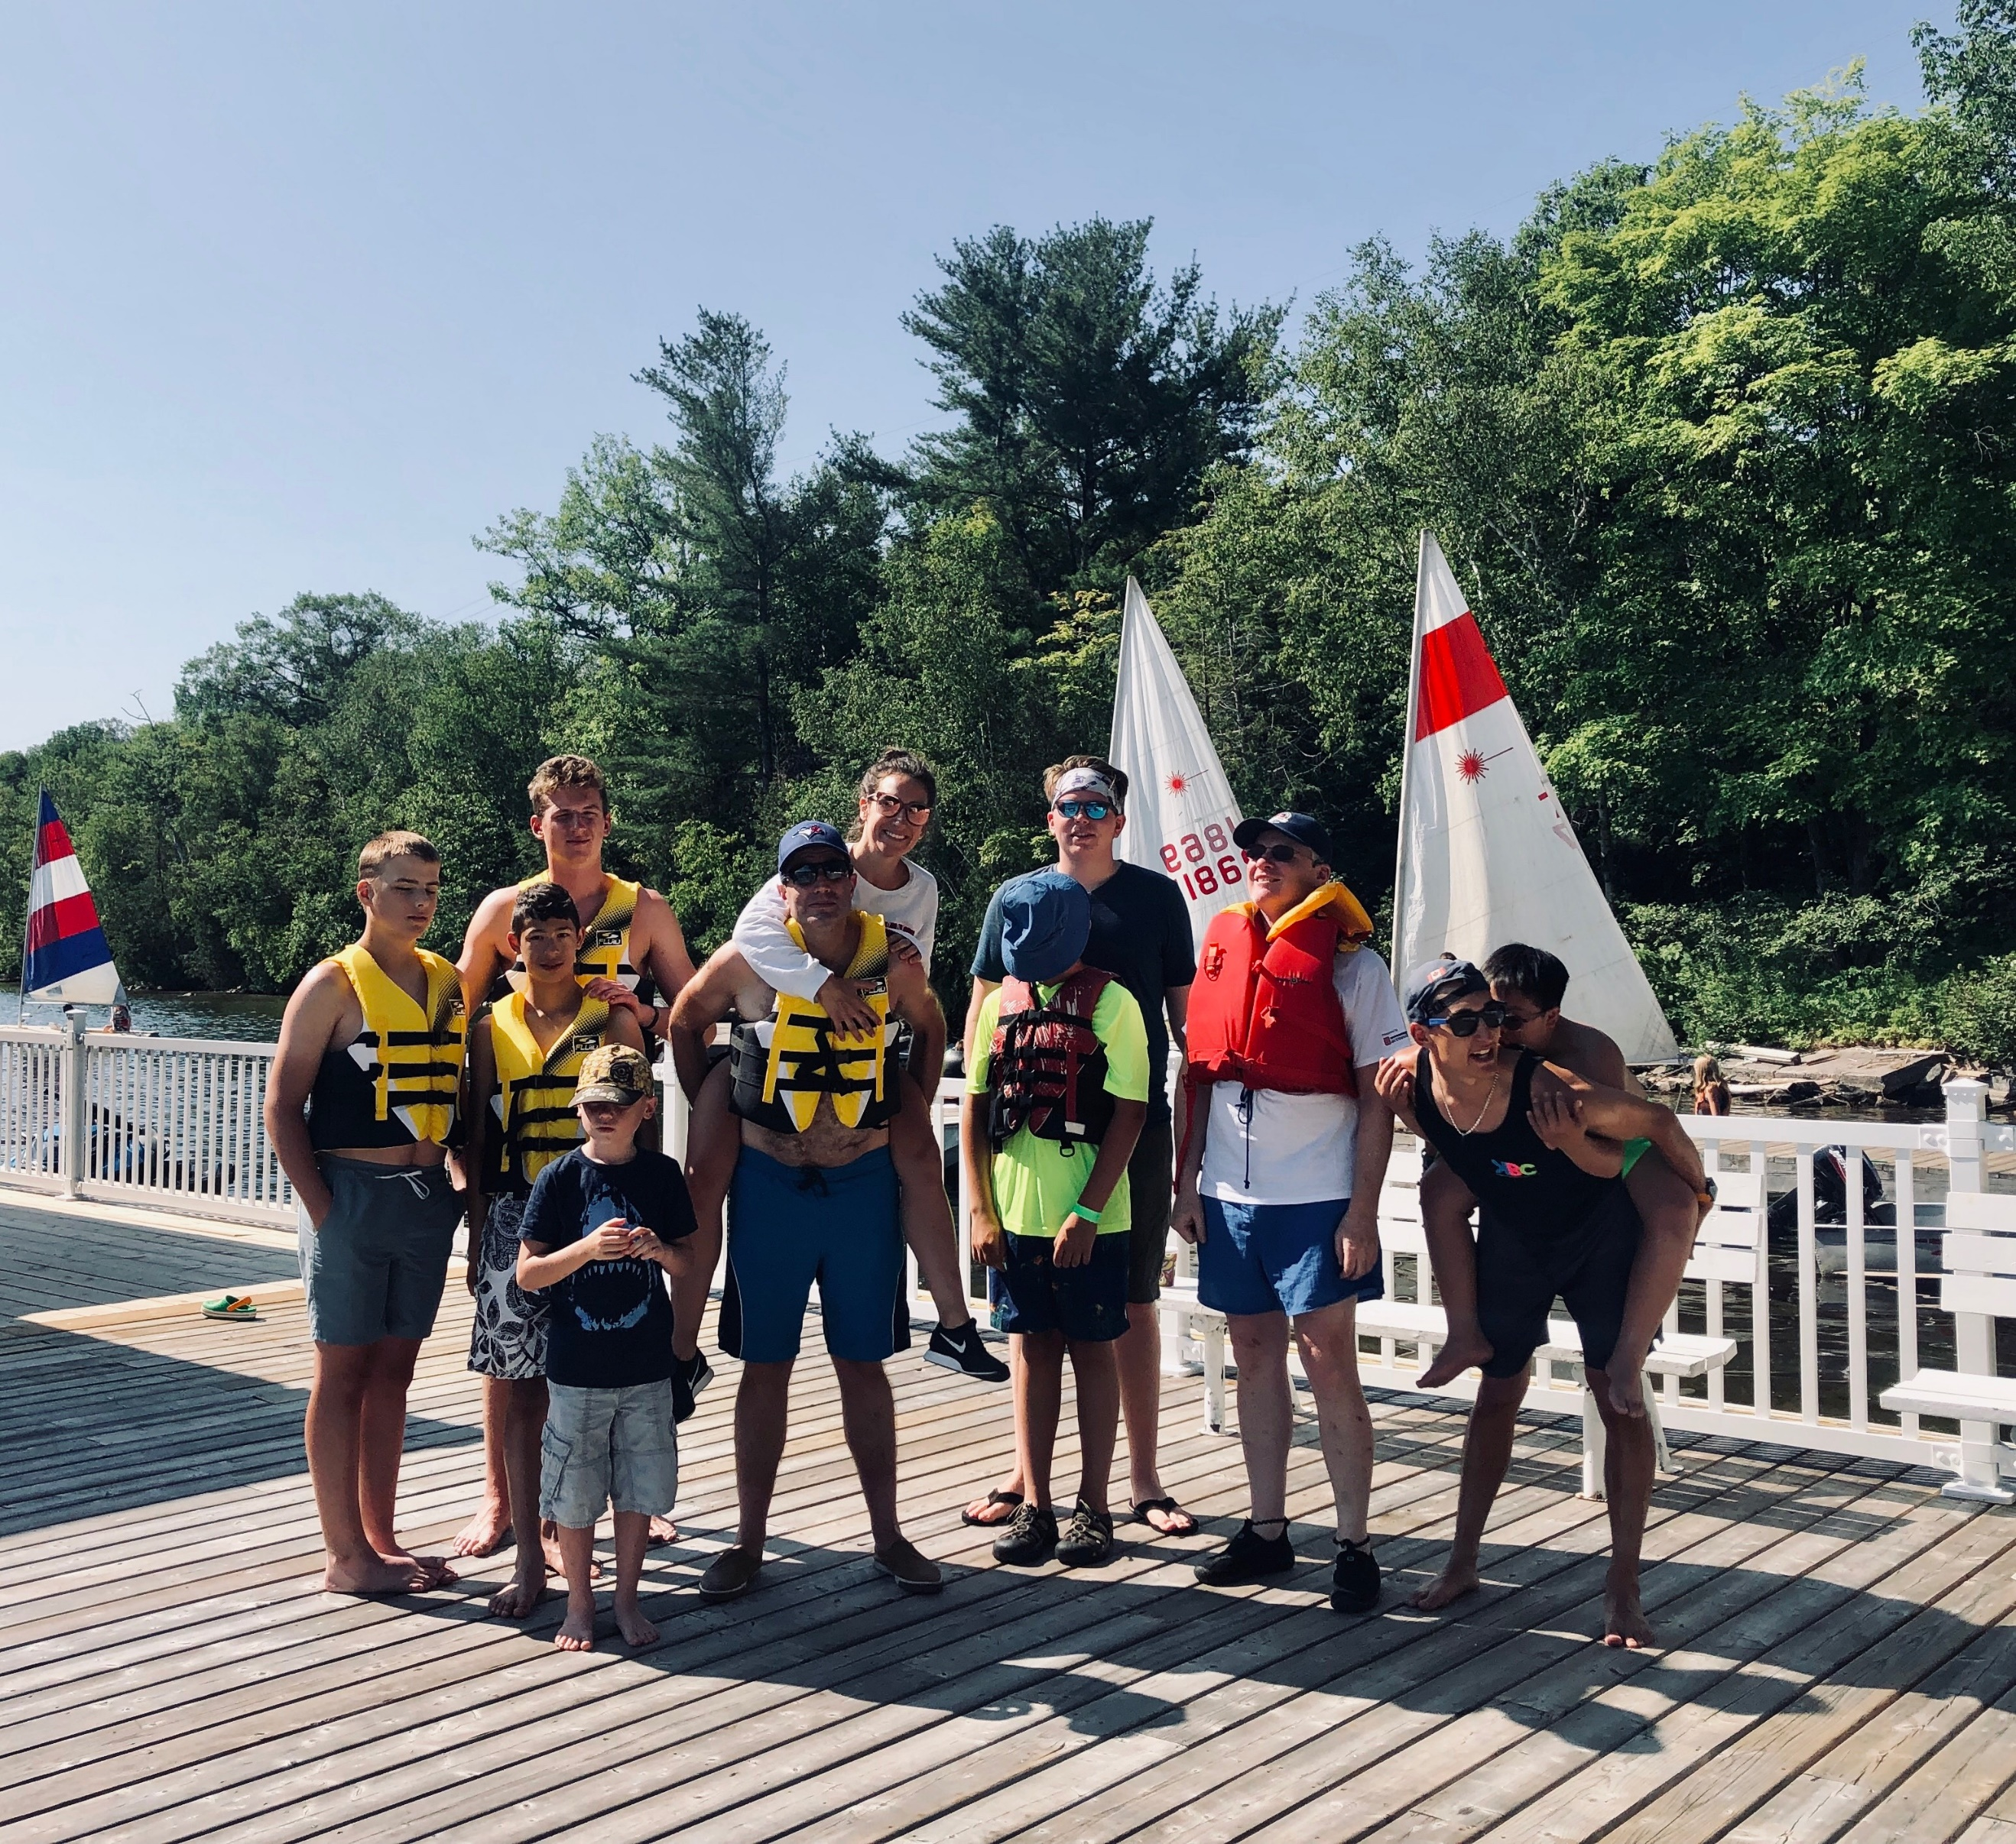
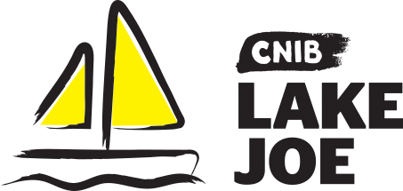

Table of Contents

About CNIB Lake Joe 3
Child & Youth Programs 6
Adult Programs (ages 19+) 9
Family Programs (all ages) 12
CNIBLakeJoe@Home Virtual Programs 14
Program Summary – by date 16
Program Summary – by age 19
Program Summary – by theme 21
COVID-19: Pandemic Precautions 23
Fee Summary 24
NEW Application / Registration Process in 2021 26
Getting to Camp 28

Please note: CNIB Lake Joe may update or make changes to the 2021 schedule. Every effort will be made to keep the programs and fees as represented; however, unforeseen circumstances, including COVID-19 health and safety protocols, may result in the substitution or cancellation of a program. We appreciate your understanding and look forward to finding the perfect program for you and your family.

About CNIB Lake Joe

We are excited to share information about our CNIB Lake Joe 2021 season, our 60th Anniversary year!

Since 1961, CNIB Lake Joe has been providing a unique blend of recreation and skills development in a safe, inclusive environment. Dedicated to providing enriching experiences for Canadians with sight loss, it's a one-of-a-kind camp in Canada. Located in the heart of Muskoka, CNIB Lake Joe is an accessible lakefront property that stretches over 12.5 acres on the northwest corner of beautiful Lake Joseph. CNIB Lake Joe is proud to be an accredited member of the Ontario Camps Association and an affiliated member of the Lifesaving Society.

We have been busy anticipating your return with new programs and camper favourites that will dazzle and delight, all while keeping your health and safety top of mind! We’re here for you. Come join us.
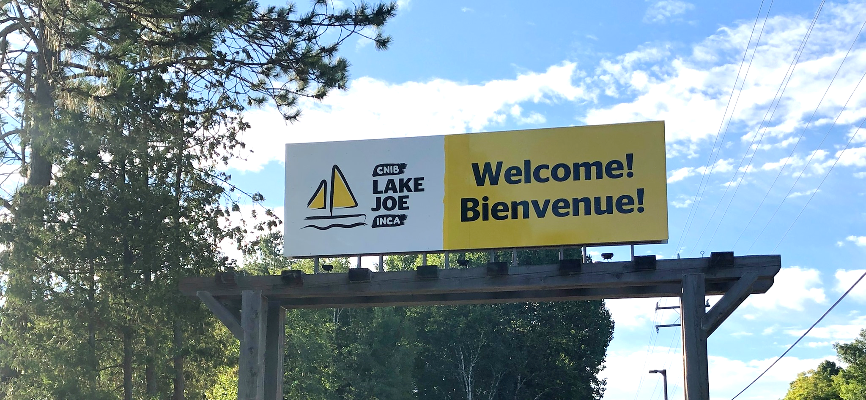

Here are just some of the activities you can enjoy at CNIB Lake Joe!

- Make a splash in Lake Joseph: fishing, paddling (canoe, kayak, stand-up paddleboard), pontoon boat cruises, sailing, swimming, tubing, waterskiing, wakeboarding, water sliding
- Get creative: music, pottery, crafts, dancing, talent shows
- Get active: basketball, tennis, volleyball, shuffleboard, mini-golf, tandem-bike riding, archery, hiking, yoga and more
- Learn new skills: in a fun, safe and supportive environment
- Explore Muskoka: on an excursion
- Rest and Relax: enjoy a book by the lake, visit with friends, new and old, around the campfire

Don’t forget, there are lots of virtual programs – online and on the phone at CNIBLakeJoe@Home where you can learn, laugh, and stay connected with your camp community!

To apply, please visit: cniblakejoe.campbrainregistration.com

For more information, contact CNIB Lake Joe:
Email: lakejoe@cnib.ca
Toll Free: 1-877-748-4028
Phone: 705-375-2630
Web: cnib.ca/lakejoe
Address: CNIB Lake Joe, 4 Joe Finley Way, MacTier, ON P0C 1H0

Child & Youth Programs

These programs are open to children and youth with sight loss. Some programs also welcome sighted siblings and friends of those with sight loss.

NEW! Welcome to CNIB Lake Joe’s Child & Youth Camp Programs (virtual)
July 12 & 30
Included in the registration fee for all child & youth programs, this Zoom meeting is your chance to meet others in advance, review housekeeping details, and get answers to your questions so you can spend ALL of your time at Lake Joe focused on fun, family and friends.

Summer Camp
Ages 8-18
July 19-24
Experience the excitement and tradition of summer camp in our fully accessible, waterfront facility. Learn new skills, try new activities and create new friendships, all while developing confidence and independence in a safe and supportive environment. This program includes a combination of group activities and individual choice programs, such as archery, court sports, swimming, music, art, sailing, canoeing and much more! Supported by experienced staff and skilled specialists, the summer camp experience will surely be a highlight for everyone!

Note: This program is open to children and youth who are participants of CNIB as well as their siblings.

Canadian Leadership Development Program (CLDP)
Ages 15-29
August 9-14
Join a group of like-minded young adults on the shores of beautiful Lake Joseph for a chance to relax, learn and have fun! This exciting week will be filled with a combination of workshops, leisure activities and social events. Learn about public speaking, advocacy, self-awareness and personal brand, all in addition to the traditional activities that make Lake Joe so special. Working with skilled facilitators, participants will have the opportunity to try new things in this fun, safe and supportive environment.

Counsellor-in-Training
Ages 15-19
August 9-14
Gain job skills while having fun at our program designed to develop leadership skills and empower youth to take an active role in camp life. This program is devoted to leadership workshops and skills development in all areas of camp. From learning about goal setting to building campfires and facilitating activities, this program is designed to help participants gain confidence and build the necessary skills to be an active member of the CNIB Lake Joe team.

Note: This opportunity is available to CNIB participants AND non-participants. Prospective participants will be required to fill out a supplementary application and participate in an interview with program staff prior to being accepted into this program. Successful completion of this program will ensure participants receive an interview for future camp staff positions but does not guarantee employment.
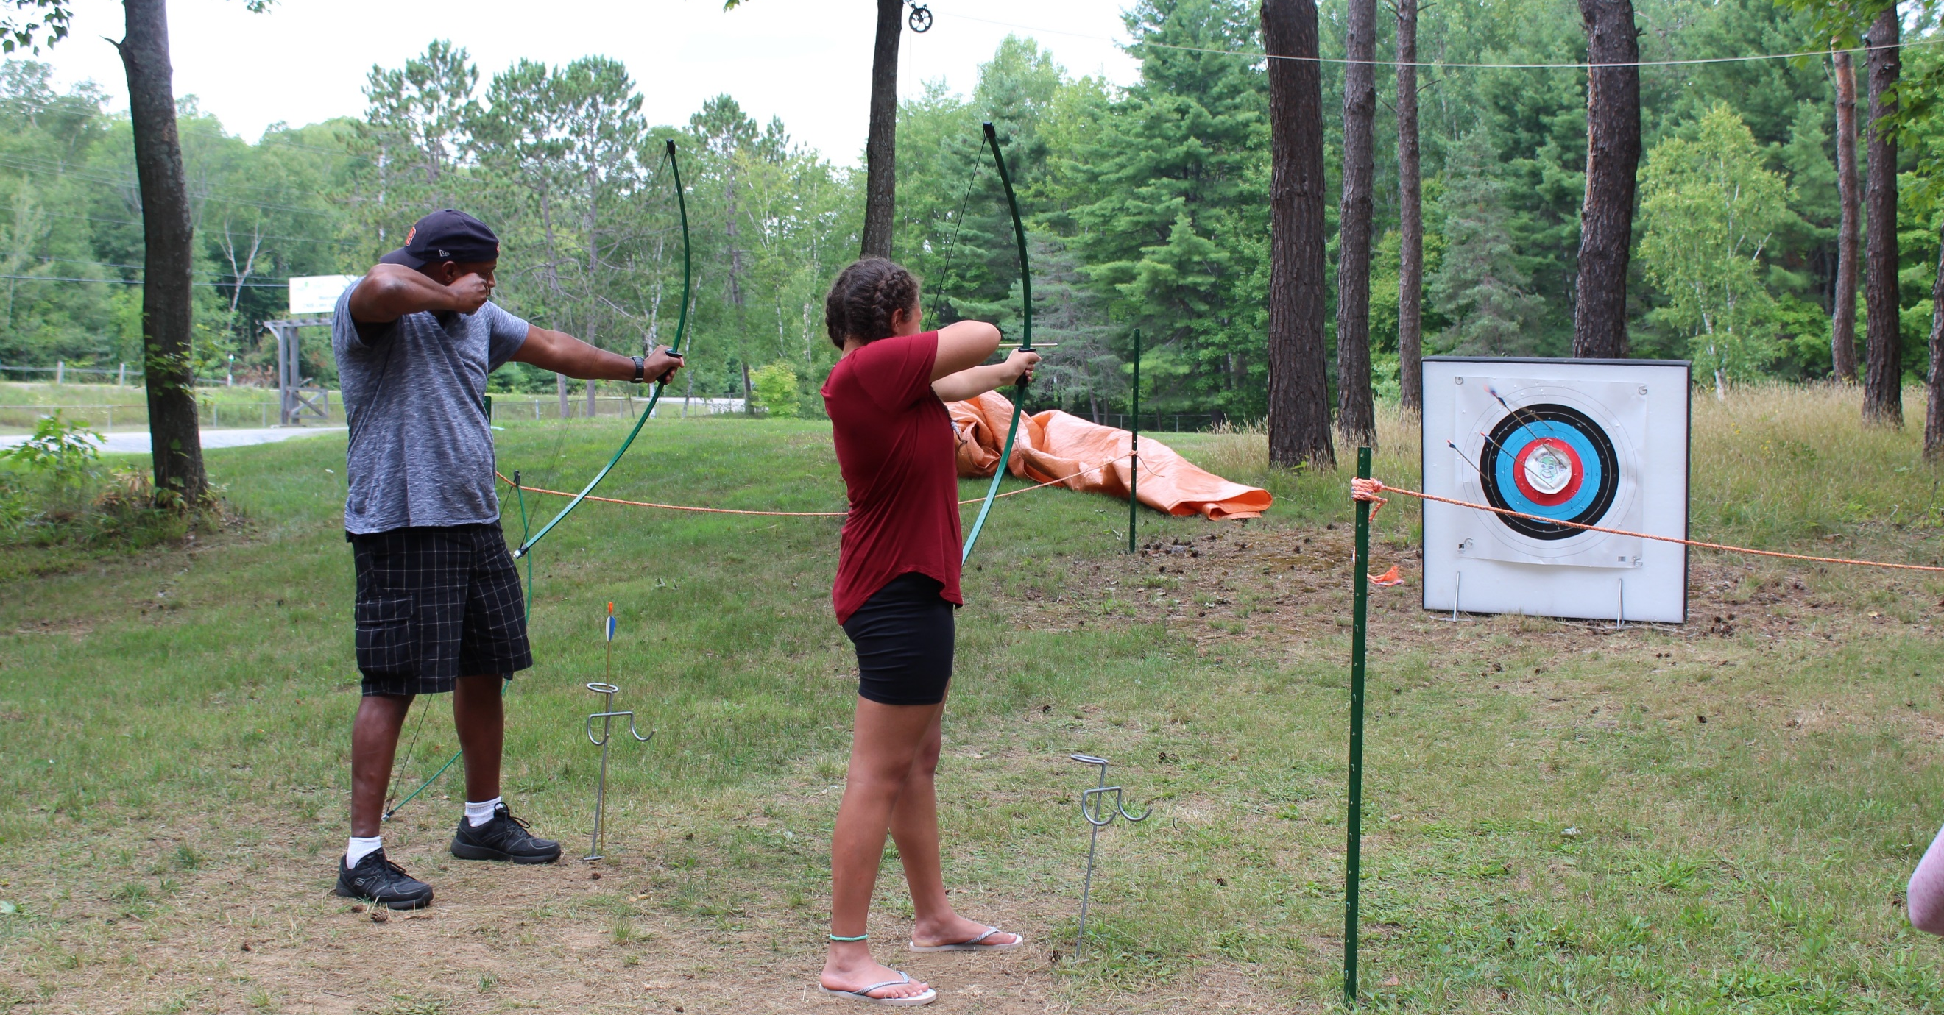
PLAY
Ages 8-18
August 16-21
Pushing Limits for Active Youth (PLAY) is for those who are interested in getting active and trying out new sports. From basketball to archery, Power Showdown to goalball, participants will try their hand at a variety of different sports and activities that encourage an active lifestyle. Health and wellness workshops including independence, healthy eating and personal care complement this adaptive sports program.

Note: This program is open to children and youth who are CNIB clients as well as their siblings.

Camp Abilities
Ages 8-18
August 16-21
This goal-based athletic program is aimed at athletic development. Participants will receive one-on-one coaching from instructors who will help guide athletes to achieve their performance goals through specialized sports programs. Participants will have the opportunity to choose from either sailing or triathlon (swim, bike, run) as their discipline, culminating in a session-end regatta or triathlon, respectively.

Note: This program is open to children and youth who are CNIB participants as well as their siblings.

Adult Programs (ages 19+)

NEW! Welcome to CNIB Lake Joe’s Adult Camp Programs (virtual)
July 2, July 5 and August 16
Included in the registration fee for adult programs, this Zoom meeting is your chance to meet others registered in advance, review housekeeping details, and get answers to your questions so you can spend ALL of your time at Lake Joe focused on fun, family and friends.

Adult Mini-Camp (Spring)
May 25-28
Enjoy our four-day adult mini-camp to get a taste of the CNIB Lake Joe experience. Enjoy all the classic camp activities like pontoon cruises, tandem biking and campfires. Try out our new pizza oven, a game of basketball or shuffleboard on the new sports court.

Adult Adventure Program
June 7-11
Start your adventure high atop the canopy on a challenge course before you head into the wilderness for a multi-day canoe trip in Algonquin Park. Facilitated by skilled staff, you will paddle, portage, cook outdoors and camp while connecting with nature and other like-minded individuals.

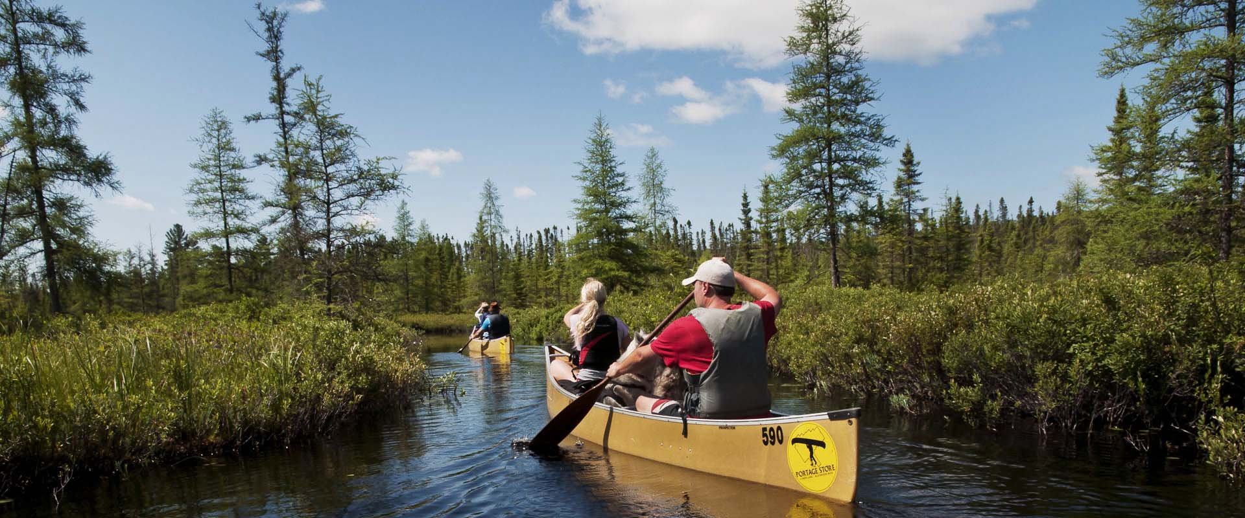
Note: This program requires a degree of fitness. You will be required to fill out a supplementary application and may require a signed letter from a physician to participate.

Adult Weeks
#1 July 12-17
#2 July 26-31
#3 August 23-28
Escape and spend a week on the shores of beautiful Lake Joseph in Muskoka. Whether you are seeking adventure or relaxation, we have something for you. Choose from a variety of activities, such as swimming, sailing, fishing, outdoor cooking, art and music, allowing you to connect with others who have similar interests. Try out our new waterslide or try your hand at pizza making in our new outdoor pizza oven. End your days around the campfire with friends, new and old. Join us for an unforgettable, life-changing experience this summer!

Canadian Leadership Development Program (CLDP)
Ages 15-29
August 9-14
Join a group of like-minded young adults on the shores of beautiful Lake Joseph for a chance to relax, learn and have fun! This exciting week will be filled with a combination of workshops, leisure activities and social events. Learn about public speaking, advocacy, self-awareness and personal brand, all in addition to the traditional activities that make Lake Joe so special. Working with skilled facilitators, participants will have the opportunity to try new things in this fun, safe and supportive environment.

Counsellor-in-Training
Ages 15-19
August 9-14
Gain job skills while having fun at our two-week program designed to develop leadership skills and empower youth to take an active role in camp life. This program is devoted to leadership workshops and skills development in all areas of camp. From learning about goal setting to building campfires and facilitating activities, this program is designed to help participants gain confidence and build the necessary skills to be an active member of the CNIB Lake Joe team.

Note: This opportunity is available to CNIB participants AND non-participants. Prospective participants will be required to fill out a supplementary application and participate in an interview with program staff prior to being accepted into this program. Successful completion of this program will ensure participants receive an interview for future camp staff positions but does not guarantee employment.

Adult Mini-Camp (Fall)
October 5-8
Fall in Muskoka! What a beautiful time to be at CNIB Lake Joe! Enjoy our four day mini-camp to get a taste of the camp experience. Enjoy all the classic camp activities like pontoon cruises, refreshing swims, fall hikes, cozy campfires, and devouring delicious treats from our brand-new outdoor pizza oven.

NEW! Fall Adult Fishing Getaway
October 13-15
Participants will be partnered with an angler to explore fishing opportunities here in Muskoka! Participants will learn different techniques and strategies on the hunt for the big one while participating in fun challenges throughout the day. Fish on!

Note: Limited spaces available. Types of fishing boats used will vary and will be piloted by volunteers.

Family Programs (all ages)

NEW! Welcome to CNIB Lake Joe’s Family Camp Programs (virtual)
June 28 and August 23
Included in your program registration fee, this Zoom meeting is your chance to meet other families in advance, review housekeeping details, and get answers to your questions so you can spend ALL of your time at Lake Joe focused on fun, family and friends.

Family Weeks
#1: July 5-10
#2: August 2-7
#3: August 30-September 4
Our family weeks give people with sight loss and their families an opportunity to enjoy time together in the splendour of Muskoka on beautiful Lake Joseph. Go for a dip in the lake, take a tandem bike out for a spin, go fishing, cruise the lake, or relax by the campfire. There are activities available for all ages! We offer daily kids camp for the children and youth every afternoon, and adult evening programs with separate activities for the children. Family weeks combine the freedom of a cottage or resort with traditional summer camp activities for the whole family to enjoy!

Friends and Family Week
August 30-September 4
A traditional Lake Joe family week that is also open to friends of Lake Joe – current or previous CNIB staff and volunteers. Join us for an unforgettable week filled with swimming, sailing, canoeing, campfires, talent show and more! A chance for family and friends of Lake Joe to share the magic with their loved ones!

NEW! Family Fall Colours Adventure Weekend
October 1-3
Everyone flocks to Muskoka in the summer, but residents say that the fall is their favourite time of year. The water is still warm, the evenings are cool for sleeping, and the changing colours of the leaves is a feast for the senses. Bright orange, red, and yellow trees sparkle while fallen leaves rustle in the wind and crunch under foot. This is the perfect way to stretch a summer vacation.
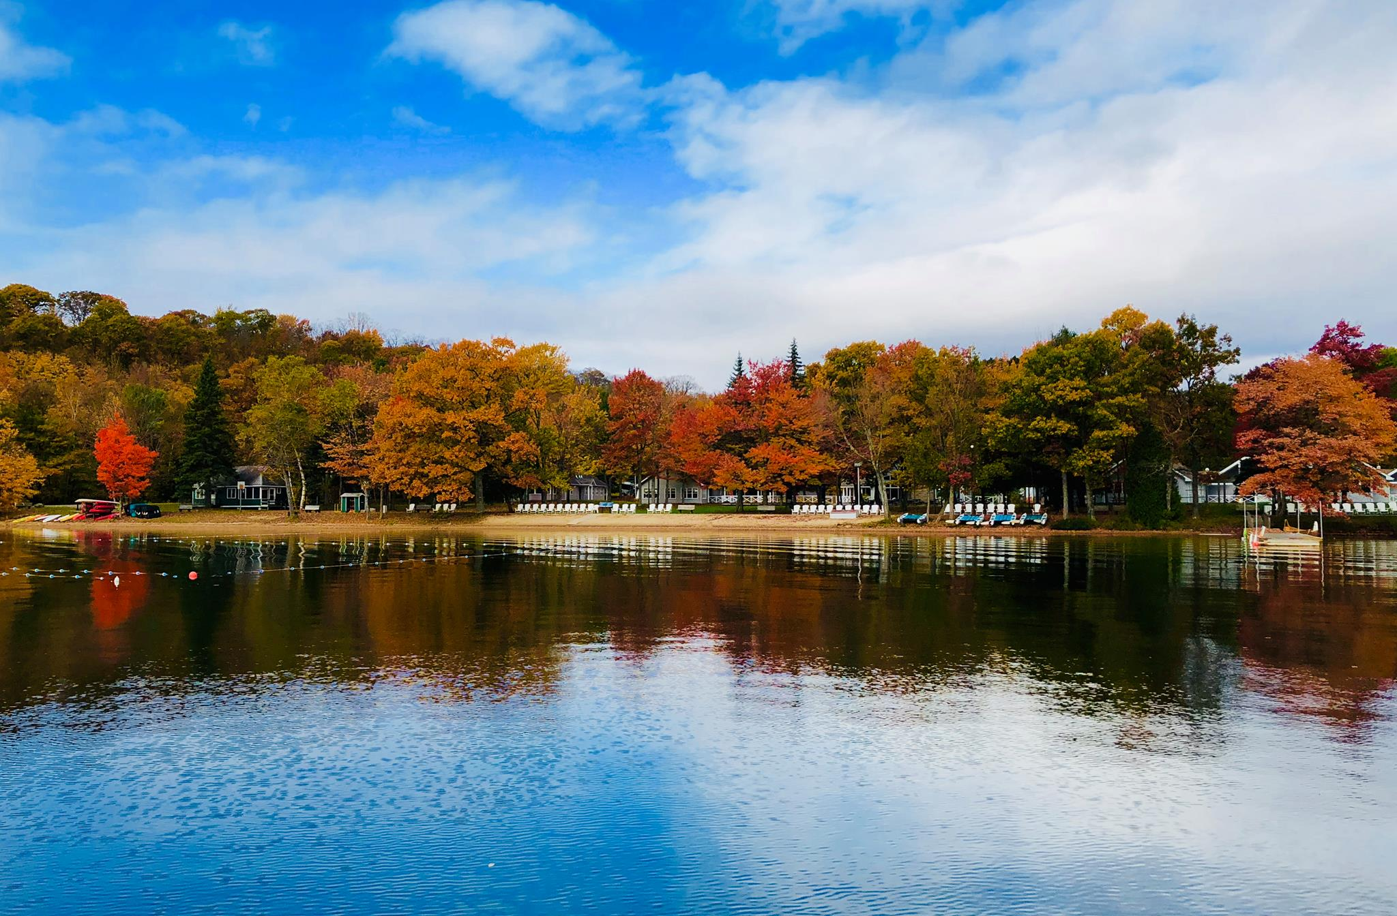

NEW! Family Halloween Retreat
October 29-31
Have a boo-tiful time at our first-ever family-friendly Halloween retreat. There will be lots of treats (and a few tricks) including spooky story-telling at the campfire, creepy crafts, costumes and more. Parents can enjoy the fun-ky kid-focused activities as well as games for grown-ups.

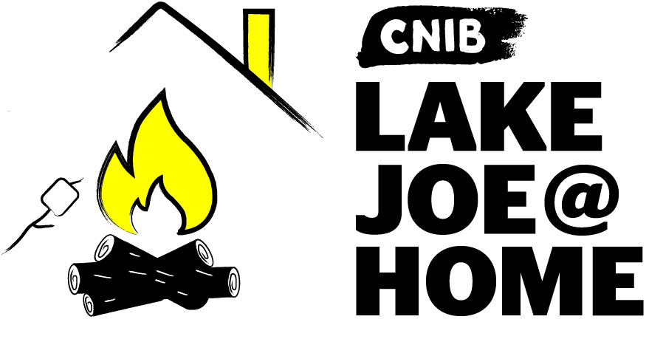

CNIBLakeJoe@Home Virtual Programs

Our virtual programs keep our camp community connected all year long. If you haven’t already participated, please visit CNIBLakeJoe@Home and join us! These programs are offered at no cost. Pre-registration is required.

CNIB Lake Joe Coffee Break
Tuesdays, 9-10 a.m. Eastern Time
Join us Tuesday mornings for conversation, laughter and a chance to reminisce about your favourite CNIB Lake Joe memories. Pour yourself a coffee, tea, or beverage of choice, login and connect with your friends from Lake Joe.

Zoom registration link: https://cnib.zoom.us/meeting/register/tJ0pdOGqrTguHtFv8E4yqaCnPgVKRge8FEWO

Curiosity Corner
First Monday of each month from 3-4 p.m., Eastern Time
Keep curious and engaged with lifelong learning. In this monthly session we will be inviting special guests and experts to inform and inspire us on a variety of interesting topics!
- December 5: Beer Talk with Muskoka Brewery Brewmaster Will Garrett
- January 11: In the Kitchen with Kiri Butter, CNIB Program Lead and creative kitchen and garden guru
- February 1: Protect Yourself from Fraud with Ted Schendera, Detective Sergeant, Health Fraud Investigation Unit, Investigation and Support Bureau, with the Ontario Provincial Police

Zoom registration link: https://cnib.zoom.us/meeting/register/tJwucOirrDMrGtGaZC2WBGD3Dh7Pd-2um-kU

CNIB Lake Joe Trivia
The last Thursday of the month from 3-4 p.m. Eastern Time
Test your knowledge in a friendly quiz competition as you laugh and learn at the same time! There will be questions for all ages.

Zoom registration link: https://cnib.zoom.us/meeting/register/tJ0rfu-qqzIsHdFbuxHkWnq-nrelhKEm4LwN

But wait, there’s more!
New CNIBLakeJoe@Home virtual sessions are always being added. We also encourage you to check out hundreds of CNIB Foundation virtual programs to connect with friends, new and old!

Program Summary – by date

January:
- Weekly Coffee Break (virtual)
- Curiosity Corner (virtual): January 11
- CNIB Lake Joe Trivia (virtual): January 28
- Curiosity Corner (virtual): February 1

February:
- Weekly Coffee Break (virtual)
- Curiosity Corner (virtual): February 1
- CNIB Lake Joe Trivia (virtual): February 25

March
- Weekly Coffee Break (virtual)
- Curiosity Corner (virtual): March 1
- CNIB Lake Joe Trivia (virtual): March 25

April
- Weekly Coffee Break (virtual)
- Curiosity Corner (virtual): April 5
- CNIB Lake Joe Trivia (virtual): April 29

May
- Weekly Coffee Break (virtual)
- Curiosity Corner (virtual): May 3
- Spring Adult Mini-Camp: May 25-28
- CNIB Lake Joe Trivia (virtual): May 27

June
- Weekly Coffee Break (virtual)
- Curiosity Corner (virtual): June 7
- Adult Adventure Program: June 7-11
- Welcome to Lake Joe Orientation Session - Families (virtual): June 28
- CNIB Lake Joe Trivia (virtual): June 24

July
- Welcome to Lake Joe Orientation Session - Adults (virtual): July 2
- Welcome to Lake Joe Orientation Session - Adults (virtual): July 5
- Family Week #1: July 5-10
- Welcome to Lake Joe Orientation Session - Youth (virtual): July 12
- Adult Week #1: July 12-17
- Summer Camp: July 19-24
- Welcome to Lake Joe Orientation Session - Youth (virtual): July 30

August
- Family Week #2: August 2-7
- Canadian Leadership Development Program (ages 15-29): August 9-14
- Counsellor-in-Training (ages 15-19): August 9-14
- Welcome to Lake Joe Orientation Session - Adults (virtual): August 16
- PLAY: August 16-21
- Camp Abilities: August 16-21
- Welcome to Lake Joe Orientation Session - Families (virtual): August 23
- Adult Week #3: August 23-28
- Family Week #3: August 30-September 4
- Friends and Family Week: August 30-September 4

October
- Family Fall Colours Adventure Weekend: October 1-3
- Fall Adult Mini-Camp: October 5-8
- Fall Adult Fishing Getaway: October 13-15
- Family Halloween Retreat: October 29-31

Program Summary – by age

Children (8-18)
- Welcome to Lake Joe Orientation Session - Youth (virtual): July 12 & July 30
- Summer Camp: July 19-24
- PLAY: August 16-21
- Camp Abilities: August 16-21

Youth (15-29)
- Canadian Leadership Development Program (ages 15-29): August 9-14
- Counsellor-in-Training (ages 15-19): August 9-14

Adults (19+)
- Curiosity Corner (virtual)
- Coffee Break (virtual)
- Spring Adult Mini-Camp: May 25-28
- Adult Adventure Program: June 7-11
- Welcome to Lake Joe – Adults (virtual): July 2 & July 5
- Adult Week #1: July 12-17
- Adult Week #2: July 26-31
- Canadian Leadership Development Program (ages 15-29): August 9-14
- Counsellor-in-Training (ages 15-19): August 9-14
- Welcome to Lake Joe – Adults (virtual): August 16
- Adult Week #3: August 23-28
- Fall Adult Mini-Camp: October 5-8
- Fall Adult Fishing Getaway: October 13-15

Family / All Ages (adult + child)
- CNIB Lake Joe Trivia (virtual)
- Welcome to Lake Joe Orientation Session - Families (virtual): June 28 & August 23
- Family Week #1: July 5-10
- Family Week #2: August 2-7
- Family Week #3: August 30-September 4
- Friends and Family Week: August 30-September 4
- Family Fall Colours Adventure Weekend: October1-3
- Family Halloween Retreat: October 29-31

Program Summary – by theme

Youth Leadership
- Canadian Leadership Development Program (ages 15-29): August 9-14
- Counsellor-in-Training (ages 15-19): August 9-14

Adventure
- Adult Adventure Program: June 7-11
- Family Fall Colours Adventure Weekend: October 1-3
- Fall Adult Fishing Getaway: October 13-15

Athletic/Sports Skill-building/Outdoor "Active" focus
- Adult Adventure Week: June 15-19
- PLAY (ages 8-18): August 16-21
- Camp Abilities (ages 8-18): August 16-21
- Family Fall Colours Adventure Weekend: October 1-3
- Fall Adult Fishing Getaway: October 13-15

"Classic" Camps
- Family Week #1: July 5-10
- Adult Week #1: July 12-17
- Summer Camp: July 19-24
- Adult Week #2: July 26-31
- Family Week #2: August 2-7
- Adult Week #3: August 23-28
- Family Week #3: August 30-September 4
- Friends and Family Week: August 30-September 4

Mini-Camps
- Spring Adult Mini-Camp: May 25-28
- Fall Adult Mini-Camp: October 5-8
- Family Halloween Retreat: October 29-31

Virtual Programs
- See page 12

COVID-19: Pandemic Precautions

What steps are being taken to keep everyone healthy and safe?

A return to onsite programs will mean new processes and protocols to keep everyone safe. For example, registration is based on one person per room, unless family members or people in your household bubble attend. To minimize contact and maximize safety, there will be cabin groups with dedicated staff for the week, and multiple seating options available for mealtimes. Additional cleaning and sanitization will be implemented. There will also be pre-screening for all guests, staff and volunteers and we will host virtual orientation sessions in advance of onsite programs to ensure everyone will know what to expect.

How is the onsite program schedule different in 2021?

The onsite program schedule for 2021 has been planned with health and safety as our main priority. With only one person in each room for safety, there will be fewer people onsite each week. Extra weeks and exciting new programs have been added to provide more spaces for people to get back to camp. Depending on how many people are interested in attending onsite programs, there may be a limit of one week per person to ensure more people have the chance to attend. To provide a 48-hour period for sanitization between weeks, guests will arrive Monday and depart Saturday.

Fee Summary

All camp experiences include meals, single accommodations, and all on-site programs and activities. Thanks to the generosity of CNIB Foundation supporters, camp registration fees are highly subsidized to keep camp fees as low as possible. Further subsidies are available for those who qualify.

Although our costs to operate onsite programs will increase with additional cleaning and sanitizing requirements, we are holding our 2019 rates. We will not be charging more for single rooms this year as this is required for safety. If you paid a deposit for the 2020 season and opted to have it carried over (deferred to be used towards 2021) you will not be required to pay another deposit at this time.

For more information, visit cnib.ca/lakejoe, email lakejoe@cnib.ca, or call
1-877-748-4028 or 705-375-2630.

Children & Youth Programs | Fee | Deposit  (due April 1-30)
Summer Camp (ages 8-18)  - July 19-24 | $460 | $50
PLAY (ages 8-18)  - August 16-21 | $460 | $50
Camp Abilities (ages 8-18)  - August 16-21 | $460 | $50
Counsellor in Training (ages 15-19)  - August 9-14 | $460 | $50
Canadian Leadership Development Program (ages 15-29)  - August 9-14 | $460 | $50

Adult Programs | Fee | Deposit  (due April 1-30)
Adult Mini-Camps  - Spring, May 25-28  - Fall, October 5-8 | $415 | $50
Adult Adventure Program  - June 7-11 | $690 | $100
Adult Weeks  - #1, July 12-17  - #2, July 26-31  - #3, Aug 23-28 | $690 | $100
Fall Adult Fishing Getaway  - October 13-15 | $275 | $50

Family Programs | Fee | Deposit  (due April 1-30)
Family Weeks  - #1, July 5-10  - #2, Aug 2-7  - #3, Aug 30-September 4  (also CNIB Friends & Family Week) | Call for details about Family Week fees. | $25 for each family member
Family Fall Colours Adventure Weekend  - October 1-3 | Call for details about Family Week fees. | $25 for each family member
Family Halloween Retreat  October 29-31 | Call for details about Family Week fees. | $25 for each family member

NEW Application / Registration Process in 2021

This year, there is a new application/registration process to help us support you as we plan for a successful onsite camp season.

If you need assistance at any time, please email lakejoe@cnib.ca or call the office at 705-375-2630 or 1-877-748-4028.

Step 1 - Application: December 1, 2020 - January 8, 2021
If you would like to attend an onsite program at Lake Joe (when it is safe to do so), please let us know by using the application link: https://cniblakejoe.campbrainregistration.com/

You will be asked for up to three top program choices. This information will help us determine the demand for each program/week. No deposit or payment will be collected at this time. Please note that while we will make every attempt to accommodate requests, due to limited spaces this year for enhanced safety, application to the program does not guarantee attendance.

Step 2 – Our CNIB Lake Joe Staff will contact you
If you apply before January 8, our staff will contact you in January to provide an update about the status of your application. We will call to let you know which, if any, of your top three choices has availability and will then update your application to a registered status.

We take the time to get to know you and are here to answer your questions. We will work with you to ensure every detail is considered:
- accommodation needs
- dietary requirements
- special medical supports
- transportation
- and more!

General Registration: February 1, 2021
For people who do not apply before January 8, General Registration will open February 1, 2021 for all remaining onsite camp program spaces.

Payments
Deposits will be due between April 1-30, 2021 with the balance owing 30 days before your arrival to camp. For example, if your camp program starts July 12, your registration fee will be due June 12.

For more information, visit cnib.ca/lakejoe, email lakejoe@cnib.ca, or call
1-877-748-4028 or 705-375-2630.

To register, please visit: cniblakejoe.campbrainregistration.com

Getting to Camp

We welcome guests from across Canada and around the world!

CNIB Lake Joe is located at: 4 Joe Finley Way, MacTier, ON P0C 1H0

Arriving by Car?

Directions from Toronto/Southern Ontario*
- Take Hwy 400 north just past Barrie to Hwy 400 extension (formerly Hwy 69)
- Continue north on Hwy 400 to exit 189 for ON-69 toward MacTier/Gravenhurst
- Merge onto Lake Joseph Road (formerly Hwy 69) past Hwy 169
- Turn right onto Joe Finley Way

*GPS often provides directions to take Hwy 407 toll road. The toll road saves approximately 10 minutes from the drive (approx. 2 hours), but at a cost. Please check a website like mapquest.ca for directions or remember to adjust GPS settings.

Directions from Northern Ontario
- Take Hwy 69 south to Hwy 400 south
- Continue south on Hwy 400 to exit 207 for ON-69 toward MacTier/Gravenhurst
- Merge onto Lake Joseph Road (formerly Hwy 69)
- Turn left onto Joe Finley Way

Directions from Eastern Ontario
- Take Hwy 417 west to Bruce St/County Road 20 to Hwy 60 west
- Continue on Hwy 60 and merge onto Hwy 11 south
- Take exit 219 for Muskoka Rd 3 toward Huntsville/Aspdin
- Turn right onto Aspdin Rd/Muskoka District Road 3 (Regional Road 3 W)
- Turn right onto Hwy 141 west and turn left onto Lake Joseph Rd (formerly Hwy 69)
- Turn left onto Joe Finley Way
Parking is free but limited. Please park in one of the designated parking spaces.

Do You Need Transportation?

We are pleased to work with you to provide transportation from Pearson International Airport and Union Station in Toronto, as well as other cities within Ontario. Additional fees may apply.

Once at CNIB Lake Joe, simply head to the Welcome Centre to check-in and receive your room key. We are waiting for you!

One More Thing…

We can’t wait to welcome you to CNIB Lake Joe as our guest, but there are so many ways to enjoy CNIB Lake Joe:

- Participate in CNIBLakeJoe@Home and CNIB Foundation virtual programs
- Join our staff team
- Volunteer at Lake Joe
- Attend an event (visit cnib.ca/lakejoe for upcoming events)
- Donate
- Subscribe to the Lake Joe e-newsletter
- Follow us on Facebook and Instagram

For more information, visit cnib.ca/lakejoe, email lakejoe@cnib.ca, or call
1-877-748-4028 or 705-375-2630.

CNIB Lake Joe
4 Joe Finley Way
MacTier, ON P0C 1H0
Web: cnib.ca/lakejoe
Email: lakejoe@cnib.ca
Toll Free: 1-877-748-4028
Phone: 705-375-2630

